QUENINGTON PARISH COUNCIL

9th May 2024
To all Members of the Council

I hereby give notice that a meeting of Quenington Parish Council will be held at 7.30pm on Thursday 16th May 2024. All Members of the Council are hereby summoned to attend for the purpose of transacting the following business.

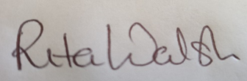

Rita Walsh, Clerk

Agenda
- Apologies for absence

- Declaration of Interest on Items on the Agenda

- To review and agree the insurance renewal

- To consider the following planning application and the parish council’s response:

Planning application no: 24/00968/FUL

Full Application for Demolition of the existing industrial building and the erection of 30
dwellings (24 houses and 6 flats) and 1000.6 sqm of office space (Class E (g) (i)) and
associated car parking, landscaping and amenity space at Godwin Pumps Ltd Coneygar
Road Quenington Cirencester Gloucestershire

- Date of next meeting – Thursday 6th June at 7.30pm

