QUENINGTON PARISH COUNCIL

4th January 2024
To all Members of the Council

I hereby give notice that a meeting of Quenington Parish Council will be held at 7.30pm on Thursday 11th January 2024. All Members of the Council are hereby summoned to attend for the purpose of transacting the following business.

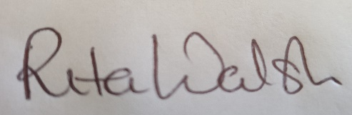

Rita Walsh, Clerk

Agenda

- Apologies for absence

- Open discussion

- Declaration of Interest on Items on the Agenda

- To receive report from County Cllr Dom Morris

- To receive report from District Cllr Fowles

- Planning
  - To consider the following applications and any received prior to the meeting.
  - To receive January 2024 Planning Report

- Minutes: To confirm the Minutes of the Council Meetings held on 9th November 2023

- Clerk’s Report

- Finance
  - To review and accept the November 2023 accounts
  - To receive an update on income and approved expenditure since 1st December 2023
  - To receive an update on Direct Debits currently in place and proposed
  - Request for authorisation to pay any outstanding invoices – Bulldog Websites (£27.50)
  - To review current spend vs budget

- To review the 2024-25 budget and agree the precept request

- To receive an update on the Speedwatch project and agree any further actions

- To review and consider adoption of a biodiversity policy

- To agree the dates of the Parish Council meetings 2024-25

- To agree the list of speakers for the Annual Parish Meeting

- Open discussion

- Date of next meeting – 14th March 2024

