QUENINGTON PARISH COUNCIL

2nd June 2023
To all Members of the Council

I hereby give notice that a Meeting of Quenington Parish Council will be held at 7.30pm in Quenington Village Hall on Thursday 8th June 2023. All Members of the Council are hereby summoned to attend for the purpose of transacting the following business.

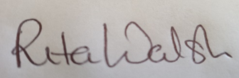

Rita Walsh, Clerk

Agenda

- Apologies for absence

- Declaration of Interest on Items on the Agenda

- To review the Internal Audit report

- To complete and approve Section 1 of the Annual Return (Annual Governance Statement) for financial year ending 31 March 2023

- To approve Section 2 of the Annual Return (Accounting Statement) for financial year ending 31 March 2023

- To review explanation of variances

- To confirm the dates of the Period for the Exercise of Public Rights

- Open discussion

- Date of Next Meeting: Thursday 13th July 2023

