QUENINGTON PARISH COUNCIL

30th May 2024
To all Members of the Council

I hereby give notice that a Meeting of Quenington Parish Council will be held at 7.30pm in Quenington Village Hall on Thursday 6th June 2024. All Members of the Council are hereby summoned to attend for the purpose of transacting the following business.

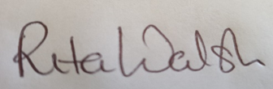

Rita Walsh, Clerk

Agenda

- Apologies for absence

- Declaration of Interest on Items on the Agenda

- Introduction to the Housing Needs Survey by Cara Loukas, Affordable Housing Manager, Gloucestershire Rural Community Council.

- To complete and approve Section 1 of the Annual Return (Annual Governance Statement) for the financial year ending 31 March 2024

- To approve Section 2 of the Annual Return (Accounting Statement) for the financial year ending 31 March 2024

- To review the explanation of variances

- To confirm the dates of the Period for the Exercise of Public Rights

- To review the Speedwatch project and agree further actions

- To review and approve the QPC response to planning application 24/00968/FUL for the Xylem site and agree further actions.

- Date of Next Meeting: Thursday 11th July 2024

