QUENINGTON PARISH COUNCIL

7th March 2024
To all Members of the Council

I hereby give notice that a meeting of Quenington Parish Council will be held at 7.30pm on Thursday 14th March 2024. All Members of the Council are hereby summoned to attend for the purpose of transacting the following business.

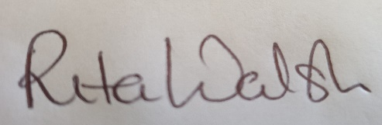

Rita Walsh, Clerk
Agenda

- To receive and accept apologies for absence

- Open discussion

- Declaration of Interest on Items on the Agenda

- To receive report from County Cllr Dom Morris

- To receive a report from District Cllr David Fowles

- Planning
  - To consider the following applications – None received
  - To receive March 2024 Planning Report

- Minutes: To confirm the Minutes of the Council Meetings held on 11th January 2024

- Clerk’s Report

- Finance
  - To review and accept the January 2024 accounts
  - To receive an update on income and approved expenditure since 1st February 2024
  - To receive an update on Direct Debits currently in place and proposed
  - Request for authorisation to pay any outstanding invoices – Marston Hill (£984.53)
  - To review current spend vs budget
  - To review and agree the bank reconciliation as at 7th March 2024

- To instruct GAPTC to appoint the internal auditor

- To receive an update on the meeting held on 7th March with the Police and Crime Commissioner to review the Speedwatch project, and to agree any further actions

- To discuss the appointment of a company to carry out the annual playground inspection

- To discuss the development of the new parish plan and agree the required actions

- To review the management of the wildflower area on Church Road and agree any required further actions

- To discuss items for the next meeting agenda

- Date of next meeting – 9th May 2024

