QUENINGTON PARISH COUNCIL

4th May 2023
To all Members of the Council

I hereby give notice that a meeting of Quenington Parish Council will be held at 8.00pm on Thursday 11th May 2023. All Members of the Council are hereby summoned to attend for the purpose of transacting the following business.

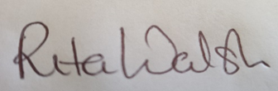

Rita Walsh, Clerk

Agenda
- Apologies for absence

- Open discussion

- Declaration of Interest on Items on the Agenda

- To receive report from County Cllr Dom Morris

- To receive update on SpeedWatch project

- Planning

  - To receive May 2023 Planning Report

- Minutes: To confirm the Minutes of the Council Meeting held on 9th March 2023

- Clerk’s Report

- Finance
9.1 To review and accept the March 2023 accounts
9.2 To agree annual subscription to GAPTC (Glos Ass of Town & Parish Councils) at £142.66
9.3 To agree annual playground inspection

- Donation for the Village Hall kitchen

- To discuss dog poo bag dispensers

- Review of Parish Plan

- Open discussion

- Date of next meeting

