Dear Councillors,

I am planning a grave stone for David’s grave. The calligrapher and carver has been given the rules from the parish Council for this. She is one of the best calligraphers in the country whom we have shown at Fresh Air two years running.

As David’s grave is in the corner of the cemetery under the lawson Cypruses, when visiting his grave it would be lovely to have a seat otherwise one stands in full sight of those coming up the hill which can be a little awkward.
The bench is designed by Matthew Burt, again a designer/maker we commission for Fresh Air and who is also known to `Lisi Ashbridge. She is planing to echo the curve of his design for the top of David’s memorial. She has just written this morning with the measurements and material of the stone, which is to dark slate. She writes- I based it on a dimensions of 90cm above ground and 51cm wide with a gentle curved top, which would make an elegant memorial stone. This is just to give you an indication - let me know once you have discussed it with your daughter and feel free to get in touch if you have any questions.

Both seem , I hope, to mark David’s founding and involvement in the Quenington Show which for 32 years was part of village life in Quenington.

I do hope that the PC is able to approve of this installation.

I have decided not to have lettering on the seat as it should be enjoyed by everyone under the trees and looking down the cemetery.

Lucy Abel Smith FSA

From: Matthew Burt <matthew@matthewburt.com>
Subject: David's Bench
Date: 15 August 2025 at 16:38:14 BST
To: David And Lucy Abel Smith <lucyabelsmith@gmail.com>

What are your thoughts Lucy? Same price as your bench. If you'd like a carved inscription you'd need to add a bit.
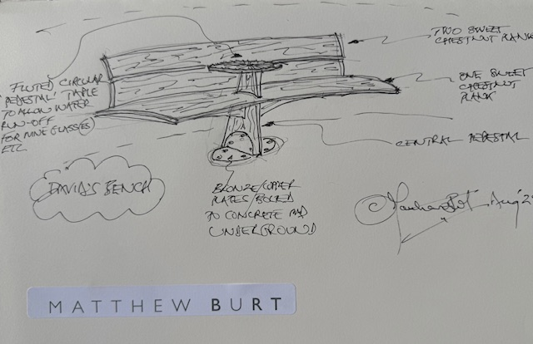

The Studio
Lime Tree Workshops, Wylye Road
Hindon, Salisbury, Wiltshire, SP3 6ER
T | 01747 820 800
E | matthew@matthewburt.com
W | matthewburt.com

Matthew Burt Ltd, registered in England 7551359.

